# CS 255 System Design Document

## UML Diagrams

### UML Use Case Diagram

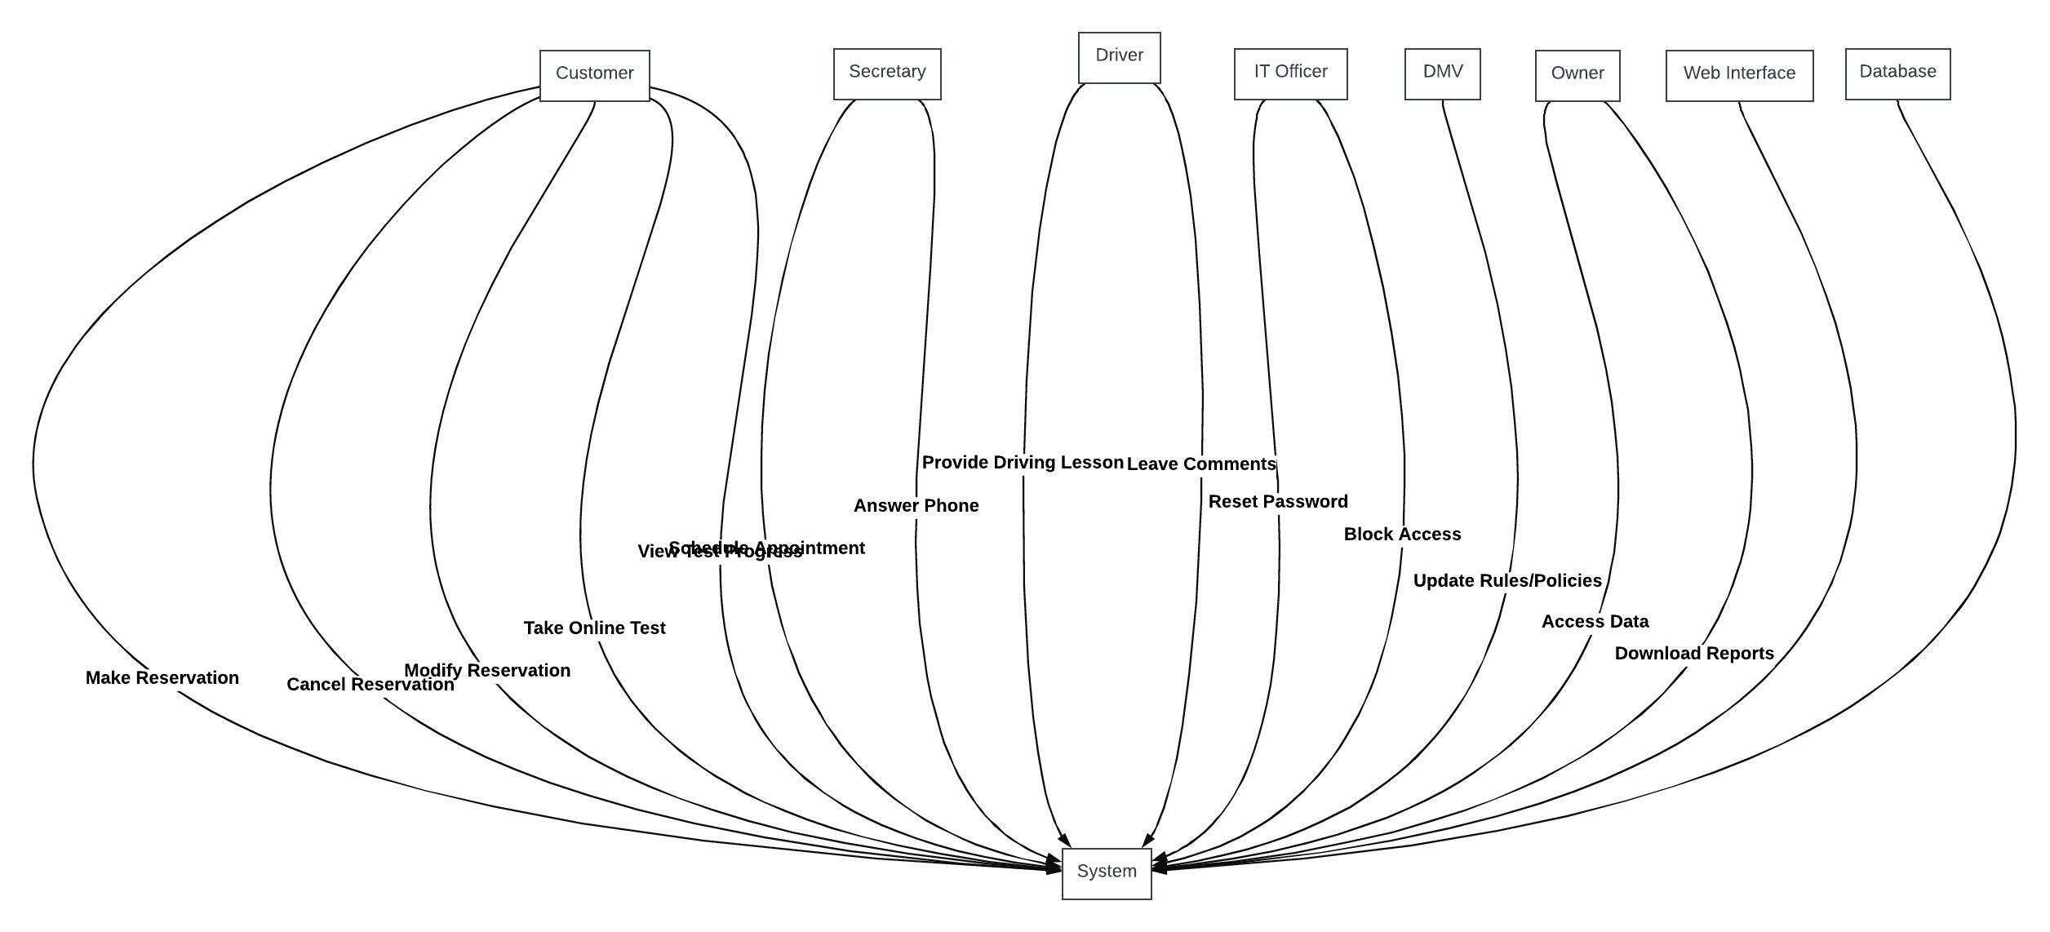

### UML Activity Diagrams

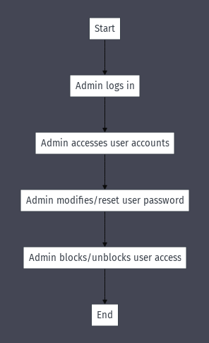

### UML Sequence Diagram

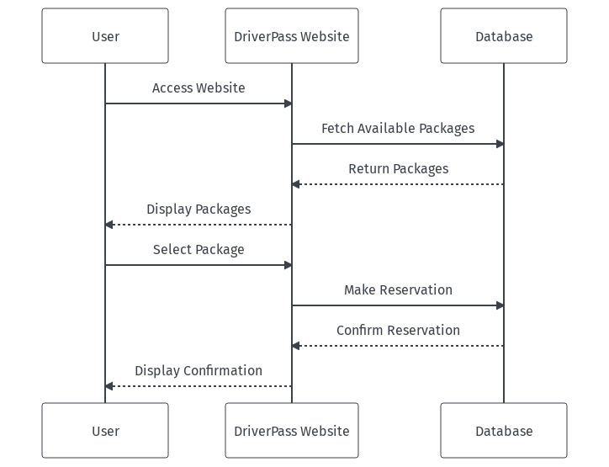

### UML Class Diagram

## Technical Requirements

***Technical Requirements for the DriverPass System***

***1. Hardware Requirements:***

* ***Server Infrastructure:*** *A robust server setup to handle the web application, database storage, and backup systems. This should be scalable to accommodate growing user traffic.*
* ***Backup Systems:*** *Redundant storage solutions to ensure data integrity and availability.*
* ***Workstations:*** *Computers with internet access for administrative and IT staff.*
* ***Mobile Devices:*** *For accessing the system on-the-go, especially for instructors to update lesson notes and for Liam to access reports.*

***2. Software Requirements:***

* ***Database Management System (DBMS):*** *A relational DBMS like MySQL or PostgreSQL to store user data, reservations, lesson packages, and other relevant information.*
* ***Web Server:*** *Software like Apache or Nginx to serve the web application.*
* ***Web Application Framework:*** *A framework like Django or Ruby on Rails to build the web application.*
* ***Cloud Storage:*** *For storing backups and any large media files, e.g., instructional videos for online classes.*
* ***Security Software:*** *SSL certificates for secure data transmission, firewall, and intrusion detection systems.*

***3. Tools:***

* ***Development Tools:*** *Integrated Development Environments (IDEs) like Visual Studio Code or PyCharm for coding.*
* ***Version Control:*** *Tools like Git for source code management.*
* ***Project Management:*** *Tools like Jira or Trello for task tracking and project management.*
* ***Continuous Integration/Continuous Deployment (CI/CD) Tools:*** *For automating testing and deployment, e.g., Jenkins.*

***4. Infrastructure:***

* ***Cloud Infrastructure:*** *Utilizing cloud providers like AWS or Google Cloud to host the application and database, ensuring scalability and reliability.*
* ***Content Delivery Network (CDN):*** *To ensure fast delivery of web content to users globally.*
* ***Networking:*** *Secure and fast internet connections, VPNs for remote access, and other networking equipment.*

***5. Additional Considerations:***

* ***Integration with DMV:*** *A system to receive updates from the DMV regarding rules, policies, or sample questions. This might require an Application Programming Interface (API) or a web scraping tool.*
* ***Mobile Application:*** *Depending on the user needs, a mobile application might be developed in the future for easier access for both instructors and students.*
* ***Training:*** *Staff training on how to use the new system, especially for the secretary handling reservations and the IT officer managing user accounts.*